Continuous Uniform Distribution

The **continuous uniform distribution**is the probability distribution of random number selection from the continuous interval between *a*and *b*. Its density function is defined by the following.

       {
         bâ1a   when  a â¤ x â¤ b
f(x) =  0      when  x < a or x > b


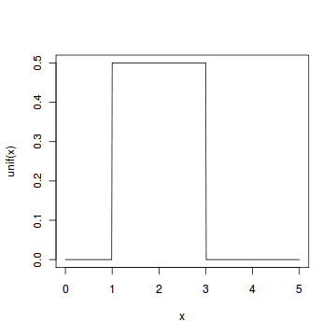

#### Problem

Select ten random numbers between one and three.

#### Solution

We apply the generation function runif of the uniform distribution to generate ten random numbers between one and three.

> runif(10, min=1, max=3)   
[1] 1.6121 1.2028 1.9306 2.4233 1.6874 1.1502 2.7068   
[8] 1.4455 2.4122 2.2171